**How to Install New exe of Pumori?(Version must be the latest one)**

Step 1:- Go to <ftp://192.168.103.3/OVERALL/PumoriIVNCCB/13January2019/>

Step 2:- copy the pumIV.exe from the folder

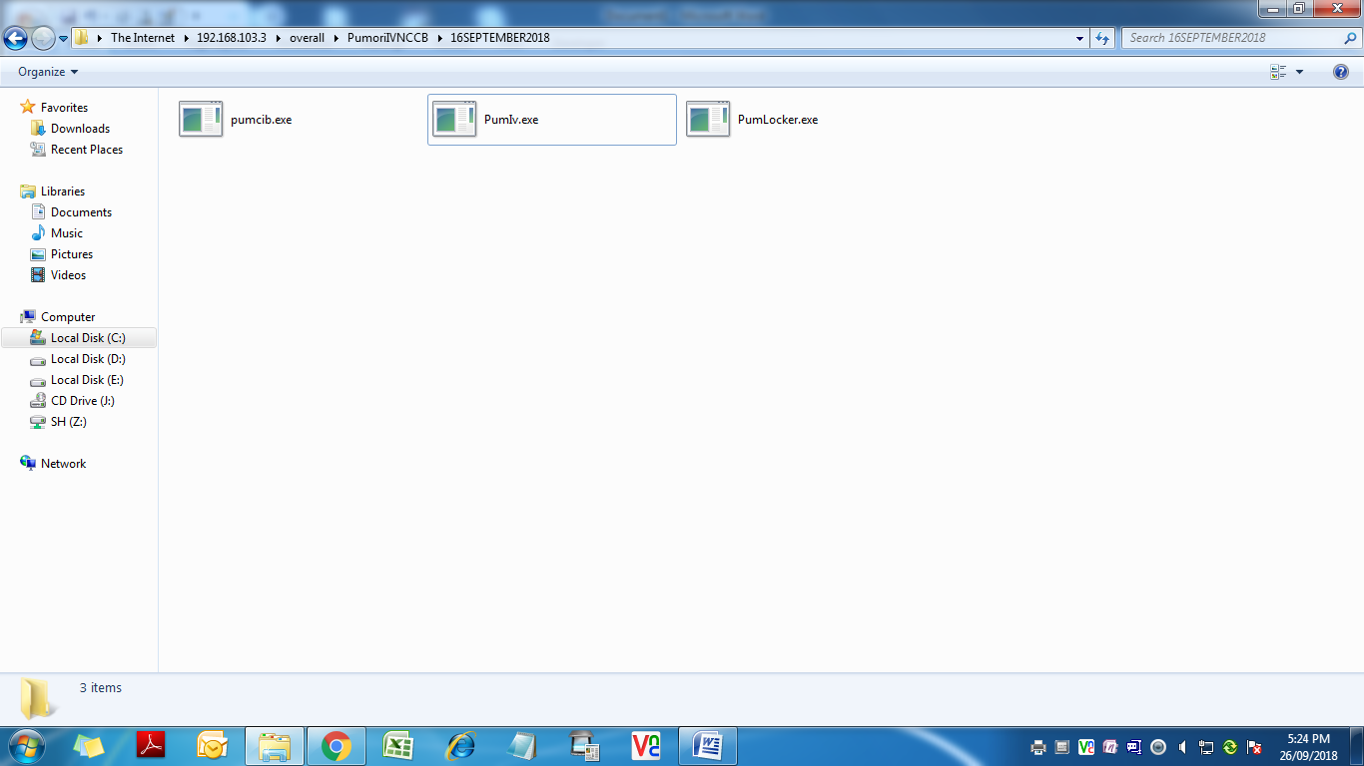

Step 3:- Right click the icon of Pumori exe on your desktop, there you can view properties.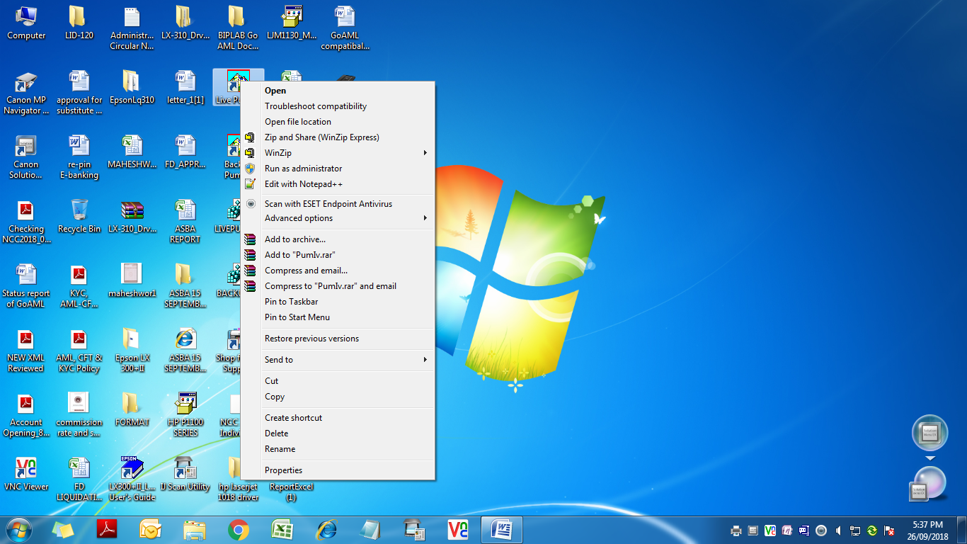

Step 4:- click on the Open file location.

Step 5:- Click on Open file Location. After clicking on open file location, it will open the folder where the Pumori exe is located.

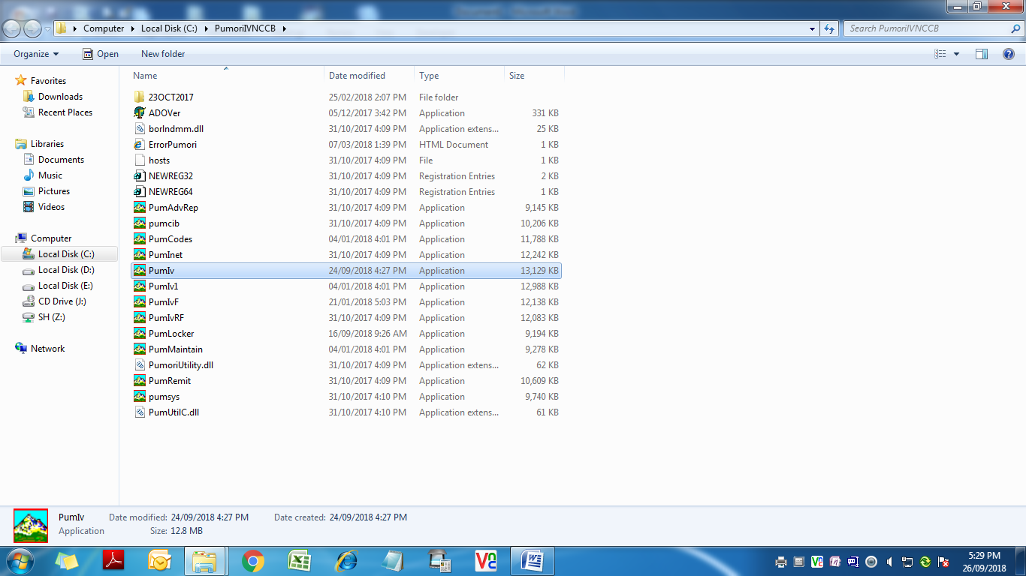

Step 6:- Now paste the copied pumIV.exe in this folder.

Step 7:- After pasting you can view the following screen.

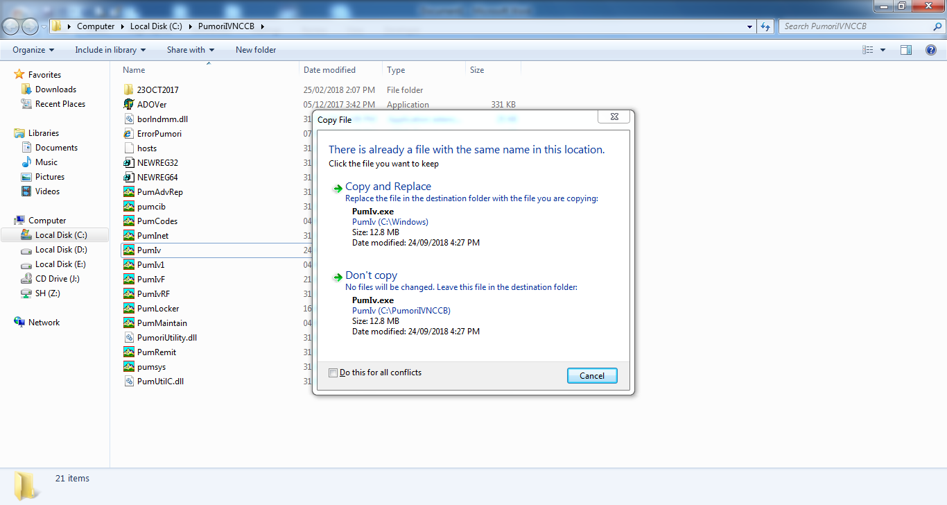

Step 8:- click on Copy and Replace.

The new exe of Pumori at your desktop is of latest version and is ready to use.